TRAVEL TIPS FOR MYANMAR

The Golden Land is a quite extraordinary place to visit, rich in wondrous sites and populated by a proud, friendly people.

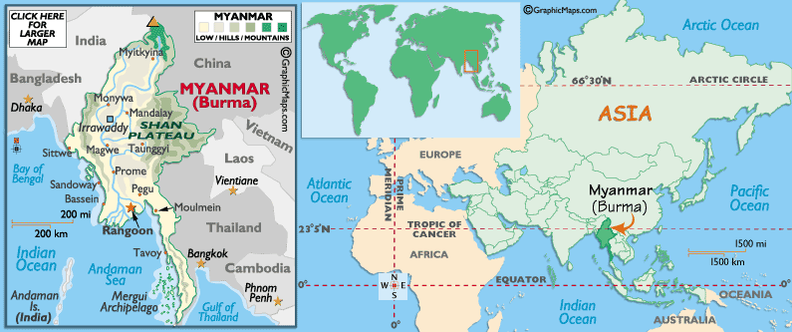

Visa: The visa is to be obtained prior to arrival in the country

Flights:
Thai Airways (TG), Singapore Airlines (SQ) fly into Yagoon.

International Airports
1. Yangon International Airport*
2. Mandalay International Airport*
3. Bagan International Airport
Overland Border Crossings
1. Tachilek – Mae Sai, Thailand
2. Kawthaung – Ranong, Thailand
3. Muse – Shwe Li, China
* indicates that visa-on-arrival facilities are available.

Airport Tax
Any passengers departing Myanmar on international flights will need to pay a departure tax of US$ 10.00 per person.

Climate
Myanmar has three seasons. *Cool Season - October through February with average temperatures 20-24 C *Hot Season - March through May with average temperatures 30-35 C *Wet Season - June through September with average temperatures 25-30 C The ideal time to visit Myanmar is during the cool season. However, even during the wet season, Yangon normally receives morning and afternoon showers while rainfall in Bagan and Mandalay is very low. The weather around Inle Lake and in Shan State is quite pleasant all year round but cold at night from December to February.

Currency
The local currency is the kyats. Since this fluctuates rapidly, please check the exchange rate before traveling, as they are subject to change. The denominations are: 1, 5, 10, 15, 20, 45, 50, 90, 100, 200, 500 and 1000. Currency exchange controls in Burma are strict. If on your own, you should avoid changing any money in or outside of tourist hotels. Also, check the denominations someone is trying to sell you to see if they are current.
Individual tourists are required on arrival at Yangon international airport to exchange a minimum of US$ 200 into FECs (Foreign Exchange Certificates), which are equivalent of the USD. Any unused foreign exchange certificates out of this amount will not be converted. The denominations are: 1, 5, 10, and 20. FEC are accepted by hotels, tourist restaurants and as admission fees. It is advisable to carry only US dollars, as other currencies might not be accepted.
Credit Cards
Credit Cards are only accepted at a very few major hotels, airlines and some international shops and restaurants. We suggest to bring a sufficient amount of cash for personal expenses. The exchange of traveler cheques as well is very difficult and time consuming. Banks are closed on Saturdays, Sundays and all public holidays.

Domestic Airlines & Flights
Air Mandalay and Yangon Airways are privately operated airlines flying throughout Myanmar. There is a 20 Kilo limit for baggage per person and excess baggage fees may be charged. We suggest you leave items not needed upcountry in Yangon and collect them upon your return.
Drinking Water
Only drink purified bottle water. Bottled water is readily available and some hotels provide complimentary. Carry a bottle with you throughout the day.
Duty Free Allowance
Two bottles of liquor, two cartons of cigarettes or 100 cigars and half litre of perfume are allowed per person. Yangon Airport arrival hall has a selection of duty free shops with a full range of items at a good price.
Gratuities & Tipping
Myanmars are genuinely happy to help foreign visitors and don't expect anything in return. But if your guide or any other person during your trip was especially kind or helpful a gratuity would be a generous gesture and greatly appreciated.

Language
The majority of the people speak Myanmar (Burmese) and English is widely used.

Mobile Phones
Hand Phones or Mobile Telephones from other countries currently do not operate in Myanmar. Customs will hold your telephone upon arrival and you can collect on your departure.
Monosodium Glutamate - (Msg) Alert
Throughout most Asian countries including Myanmar MSG (Monosodium Glutamate) - known locally as 'AJINOMOTO' - is still used in food preparation in some restaurants. Some travellers who may experience swollen feet, hands or headaches will more than likely have had a good amount of MSG in the food. It is always best to inform your guide when ordering if you do not wish it to be added to your food.
Power & Electricity
Our recommended hotels in Yangon, Mandalay and Bagan offer 24 hour power (with a generator if needed). In other more isolated areas like Kyaingtong, the Shan Hills, Kalaw, Pindaya, Taunggyi, Nyaung Shwe and Inle Lake - generated power may not always be available. Most hotel rooms have screens and mosquito nets.
Religion
The majority of the people of Myanmar are Buddhist although Christianity, Islam and Hinduism are also practiced.

Voltage
The voltage in Myanmar is 220-230 Volts AC. Most of the international hotels have their own generators. Other places may experience power cuts and voltage fluctuation which can damage equipment like computers. Please travel with the required protection for your electrical items.
What To Bring
Sun hat, sun glasses, sun protection for your face and body, prescription medicines, insect repellent and an umbrella April to October (rain or shine). An antibiotic cream for minor cuts and scratches, extra pair of prescription glasses, a small flashlight, extra passport photos, decaffeinated coffee (if you require). WHAT TO WEAR Shorts, short skirts or revealing clothing are not appropriate especially when visiting temples or any religious site. Myanmar is a conservative Buddhist culture and improper dress can be offensive. Please dress with respect for the local culture. Lightweight, easy to care clothes of cotton and cool fabrics are ideal all year round. A winter sweater or jacket and socks may be needed in the cool season when visiting up country especially around Inle Lake and Kalaw when the weather can drop to near freezing during the night. Wear sensible walking shoes which can be easily removed when required. Sandals, thongs or flip-flops (available locally) are very convenient footwear.
Air
The best way to get around in Myanmar is by flying. Air Mandalay and Yangon Airways are both reputable private airways and provide services to all regional centers. However, flights often depart early in the morning, and flight schedules are limited, particularly in the low season.

Train
The train service is wonderful for those who would like to experience the British Raj style of travel. And all types of classes are available. Some delays do occur due to climatic and technical problems.
Bus
Privately operated, air-conditioned buses are becoming more common, running from Yangon to Meiktila, Pyay, Mandalay and Taunggyi. It is not recommended to travel on public bus services.
Boat
Cruises on the major arterial rivers are also very popular and a restive form of transport for those with time on their hands. Trips can usually be arranged as part of an organized tour group.
City Transport
Within major cities taxis are safe and cheap. As in other South east Asian destinations, unmetered taxis and rickshaws are available, but it is best to establish the fare beforehand. Yangon has blue government taxis with set fares.
In most tourist destinations pony carts are used widely and available for those wanting a local experience.

Mandalay

Mandalay was Burma's capital for only 28 years but still it appears more distinguished and self-confident than other cities in Myanmar. Perhaps this is due to Mandalay Hill, which boasts marvelous view of the city and the Ayeyarwady River, and is where the temple that allegedly enshrines three of Buddha's bones is located. Or perhaps it is because of the ‘largest book in the world’, the Kuthodaw Pagoda. Mandalay provides a unique mixture of old and new, and is a spiritual centre boasting numerous old wooden monasteries and unique pagodas that date back to life as it was under the reign of Myanmar's last King.

Getting Around
Air: There are daily flights from Yangon to Mandalay via Air Bagan, Air Mandalay, Yangon Airways, and Myanmar Air. Mandalay now has an International Airport, so there are also flights from other countries directly landing to Mandalay.
Bus and Express: There are daily local express from Yangon to Mandalay and many other parts of the country.
Taxi: Pickups and vans are available to travel around Mandalay, Amarapura, Inwa, and Sagaing.
Train: Mandalay has a new Yadanarbon Central Railway Station in downtown area. It is a seven-storey complex, including two floors devoted to a hotel. The old station is on the further south of the new one. There are daily schedules from Yangon to Mandalay.
Motorbike: Motorbikes can be seen everywhere in Mandalay. Travelling by motorbike can be very convenient in local places. So, motorbikes can be rented mostly everywhere in Mandalay.
Boat: The Inland Water Transport office is located at the Gawwein Jetty at the western end of 35th Street.
Bicycle: There are several places downtown where you can rent bicycles.

Sightseeing:

The Maha Muni Buddha Image
It is the most revered Buddha image in Mandalay. It is also known as the Maha Myat Muni, or Phaya Gyi. It is the most ancient Buddha image in Myanmar. It was cast in the life-span of Lord Buddha in the seated posture of relaxed deportment, namely Bumi Phasa Mudras, symbolic of His Conquest of Mara.

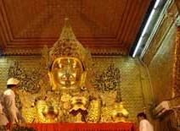

The Mandalay Hill
The Mandalay Hill is situated to the north-east corner of the Mandalay Royal Palace. It lies from north to south, its altitude being 236.5m above sea level and its height going up to 167.64m.
The Mandalay Hill is surrounded by the nine satellite hills.
One famous Buddha Image on the Mandalay Hill is the Image of Standing Lord Buddha at the top of the hill where Lord Buddha made a prophesy
It will be a memorable experience for the visitor of Mandalay to enjoy the sunset beauty over the blinking, winding Ayeyawaddy and the blue Sagaing Hill and the Min Wun ranges.

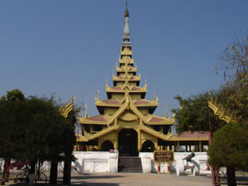

The Mya Nan San Kyaw - The Royal Golden Palace
King Mindon, who founded the Royal City of Yatanabon, built the Mya Nan San Kyaw, the Royal Palace. It is surrounded by the rectangular shaped walls, each of which stretches 8.25 kilometres long, and again by the moat which is 68.58m wide and 3.35m deep.
On 17 March, 1945, during the air raid of the British forces against the Japanese, the Royal Palace was ruined into ashes.
With the objective of re-establishing the milestone in Myanmar tradition and ancient times, when Myanmar had their own monarchs, their own royal palace and their own soverignity, the Royal Palace has been renovated and restored faithfully into its original structure.

Shopping
Mandalay is full of variety to do shopping. The new Mandalay Zaycho is the main market place in Mandalay. You can get almost anything from there. Things to shop are Acheik (Mandalay Silk Longyi), Cotton clothing, Hto Moat (greasy cakes), Laphet (Pickled tea leaves), Kadipar slippers (Velvet Slippers), Silverware, Lacquerware, Jewelry, gems and more.

YAGOON
Myanmar's capital has a very special charm. The many shady parks and beautiful lakes have earned it a reputation as the garden city of the East. Its unmistakably colonial style buildings, open markets and wide tree-lined avenues endow it with a strange mix of old world charm and modern vitality. The highlight of the cityscape is the famous Shwedagon, with its Pagoda - especially near sunset.
It towers above the Yangon landscape with serenity so unique that it is often considered as one of the wonders of the world. According to legend, this glistening, gold-covered pagoda was built over two and a half thousand years ago as a place of Buddhist worship.
Other sights of Yangon are the 2200-year-old Sule Pagoda (containing one of Buddha's hairs), the Botataung Pagoda and the Kyauk Htat Gyi Pagoda with the 233 ft/71m long Reclining Buddha. After Mandalay, Yangon became the capital of Burma in 1755.
Getting Around
Bus: There are two highway bus terminals, one known as Dagon Ayeyar Highway Bus Terminalm in Hlaing Tharyar Township, which is mainly for the buses going to the Ayeyarwaddy Division. The other terminal is Aung Mingalar Highway Bus Terminal, which is for the buses tot the cities and towns of the whole country, except the Ayeyarwaddy Division.
Boat: Boat services are available for Ayeyarwaddy Delta region. Tickets are available at Lan Thit Jetty in Seikkan Township.
Train: Myanma Railways operate 40 train-routes throughout the country. Tickets are available at Yangon Central Railway Station.
Plane: Yangon International Airport is available for both International and Domestic Flights. Domestic flight carriers are (1) Myanma Airways (2) Air Bagan (3) Air Mandalay and (4) Yangon Airways.

Must Sees:

Shwedagon Pagoda
In the capital city of Yangon, you will find the magnificent fabulous Shwedagon Pagoda. The Shwedagon Pagoda sits upon holy Singuttara Hill, visible from miles away. Shwedagon is the most sacred pagoda as it enshrines the relics of the three earlier buddhas and the eight hairs of Gautama Buddha. It rises 99.4 metres (326 feet), with the perimeter measuring 432.8 metres (1,420 feet) and glittering in gold. The very top is tipped with a 76-carat diamond. Legend has it that the Shwedagon Pagoda is 2500 years old.
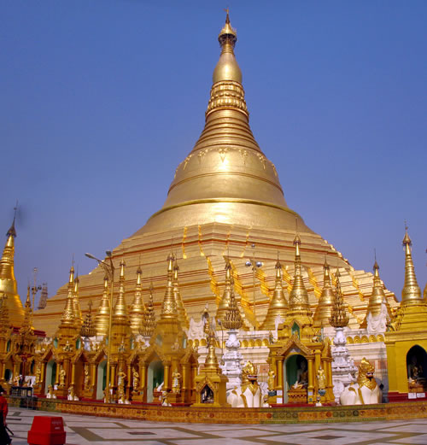

Sule Pagoda
The Sule Pagoda is an excellent landmark. It is said to be over 2,000 years old and contains a hair given by the Buddha to two Burmese merchants. Located on a roundabout in downtown Yangon. The golden pagoda is unusual in that its octagonal shape continues right up to the bell and inverted bowl. It is surrounded by small shops and all the familiar non-religious services such as of astrologists, palmists, and so on.

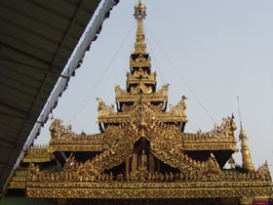

National Museum
The National Museum of Myanmar was founded in 1952 with its premises at what was once the Jubilee Hall. In 1970 the museum was moved to a more spacious building on Pansodan Street. But these premises were not originally constructed to house a museum. The present National Museum is located on Pyay Road in a splendid five-storey building constructed for the purpose in spacious and specially landscaped grounds. Priceless ancient artefacts, works of art and historic memorabilia are on display in 14 halls on four storeys. Three halls on the ground floor hold exhibits on the evolution the Myanmar script and alphabet, the Lion Throne Room and Ratanapon Period pieces

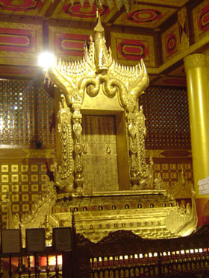

Myanmar Gems Museum
The four-storey building is situated at No.66, Kaba Aye Pagoda Road, Mayangon Township and very close to the Kaba Aye Pagoda. The jewellery shops are located on the first and second floors, while the museum is on the third floor. The gems fair and auction held twice a year in March and October. Many jewel dealers from all over the world come here at that time. These three floors of the Gems Mart present the whole range of Myanmar ruby, sapphire, period and a variety of assorted colored stones, jade, pearls in lots or embedded in exquisite jewelry, gold ware, silverware and jade figurines. These are sold in Myanmar Kyats, US$ or foreign exchange certificates (FEC).

Excursions from Mandalay

Kengtung
Kengtung (Chiang Tung) has recently opened to foreigners and the Burmese Government has officially sanctioned the border crossing to Tachilek. The town is a treasure trove of traditional architecture with old-style houses with the intricately designed wooden balconies that are so characteristic of Shan architecture.

Bagan
The birthplace of Myanmar civilization, this is a city beyond description: more than 5000 pagodas (although some of them were damaged by several earthquakes) make for an overwhelming view. Bagan is the largest archaeological site in Asia: most of the red and white pagodas were built in the 11th and 12th centuries. In modern Bagan, bullock carts dictate the pace of the day and the master tradesmen produce Myanmar's finest lacquerwave with painstaking patience.
Mount Popa
A day trip from Bagan, set amid lovely hill and forest scenery, Mount Popa is a steep sided volcanic peak dedicated to the legendary nat spirits of Myanmar. A shrine to these feared and respected traditional characters lies at the top of over 700 steps.

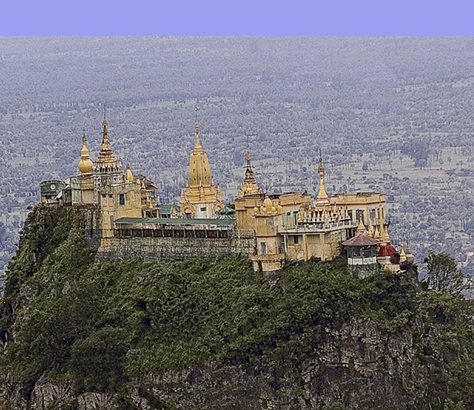
Bago
Thamala and Wimala, two Mon brothers of noble birth in 573 AD, founded Bago. According to legend, the Buddha rested on a small hillock and two Hintha birds came before him in obeisance. He prophesied that 1,660 years after his death, a city would be established on that spot which would be a capital but it was destroyed in 1757 by King Alaungpaya (the founder of the Third Burmese Empire).

Inle Lake
The center of Myanmar will captivate you very quickly: once you get used to the sight of the fishermen's peculiar ‘leg-rowing-technique’, you can enjoy the ‘floating flower beds’ and the pile dwellings on the shore. A boat trip on the lake is recommended. Here, villages are built on stilts over the lake and boats are the sole means of transport.

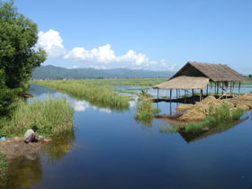

Pindaya
Situated on the shore of a picturesque little lake, Pindaya is famous for its caves, where you can see about 6000 Buddha statues of various sizes and materials. This small town in Central Myanmar is ideal for an excursion on the way from Bagan/Mandalay to Taunggyi/Inle Lake.

Ngapali
Ngapali Beach is one of the most beautiful beaches in Myanmar. Here you find peace and quiet, with isolated beaches for relaxing, or you go on trips to islands and fishing villages. Ngapali is easily and quickly accessible by plane to Thandwe and then a car transfer of about 30 minutes.

Taunggyi
The capital of the Shan minority is always worth an excursion. The marketplace with its colorfully dressed ethnic groups is a walking museum of the glory that was Shan. It is home to some of Myanmar's finest cheroot factories and boasts an impressive local market.

Kalaw
This once popular British hill station provided welcome relief during hot summers. Its cool climate, colorful markets, charming churches, and natural surrounds have preserved its appeal to this day.

Pyin Oo Lwin/Maymyo
A cool hill station, over 3047-ft./1,000 m above sea level, founded during colonial times and a worthwhile 2-hour trip from Mandalay. You can enjoy beautiful scenery, a cool climate, and an atmosphere of former days with its old buildings and botanical gardens.

Kyaiktiyo
The Golden Rock (Kyaiktiyo) Pagoda is in a spectacular location, perched on a huge, seemingly precarious boulder on the edge of a cliff. A hair of the Buddha is enshrined in the pagoda, which was supposed to have been given to a hermit monk who kept it in his topknot.
His last request was that the hair should be enshrined in a pagoda built on a rock, resembling his head. There is a popular belief that those who reach the top will grow rich, and the views are magnificent. Kyaiktiyo is only accessible in the dry season (Oct-Apr).

Indian Restaurants:
Mandalay
Golden City
Sule Pagoda Road opposite Traders Hotel

Lakshmi Indian Restaurant
Coffee shop style serving excellent Indian food at very reasonable prices ~ 225, 28th Street between 80th & 81st Streets
The Raj Indian Restaurant
1-A 5½ mile, Pyay Road, Hlaing township
Tel: (951) 514402, 514404
Email:ForumMyanmar@mptmail.net.mm
Portrait, scenic and historic paintings from bygone eras give this restaurant a nostalgic Indian ambience. Tranquility can be found in special private rooms. There is a wide variety of meat options, plus a number of vegetarian choices. The set menu ranges in price from US$2 to $5, while two-person vegetarian plates cost $2 to $3.50. Lunch is served 11:00 am to 2:30 pm, and dinner from 6 pm to 9:30 pm.
Shanti Indian Cuisine
51 Kaba Aye Pagoda Road, Mayangone township
Tel: (951) 661 216.
Within one year of its opening Shanti has become one of the most famous Indian restaurants in Yangon. The buffet-style presentation gives guests options among six meat dishes, five vegetable curries, two kinds of soups and Indian bread, with choices changing from one day to the next. Rice varieties include steamed, coconut, lemon, tomato and mango. Dessert options include homemade yogurt, fruit, coffee and curry powder tea. The buffet-style lunch and dinner is K2900 a person. Lunch is available 10:30 am to 3 pm, and dinner 6pm to 10 pm, daily.
Ashoka
77, Pyi Daundsu Yeiktha Rd, DGN Tsp
Yangon, Myanmar
Ph 221134, 227770
Bharat
356, Maha Bandoola St, (Cor of Lewis St)
Ph: 281519

Raj at Forum
1 (A), Pyay Rd , 5 1/2 Mile, Hlaing Tsp
Ph: 514401, 514402, 514404

Shanti Indian
51, Kaba Aye Pagoda St, Mayangon
Yangon, Myanmar
Ph: 01 661216

